**DOLORES HUERTA FOUNDATION CAMP LYFE**

**2023**

**HAPPENING**

**JULY 23TH - AUGUST 5TH 2023**

Apply and Join us for Camp LYFE, a free, overnight,

immersive two-week social justice and arts program for youth ages 13-18 (must still be in high school). Our talented and experienced guest artist will provide training in five key art disciplines.

Must reside in California, preference will be given to residents of the Central Valley provide training

**Dance**

**Theater**

**Spoken Word**

**Music**

**Visual Arts and Creative Media**

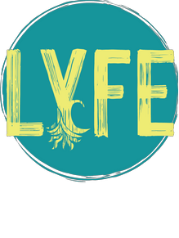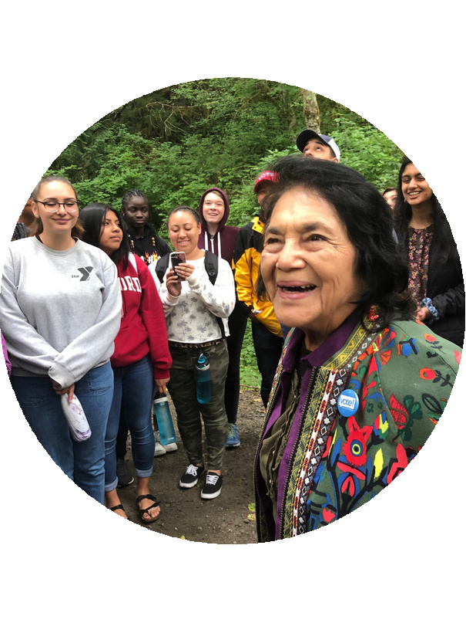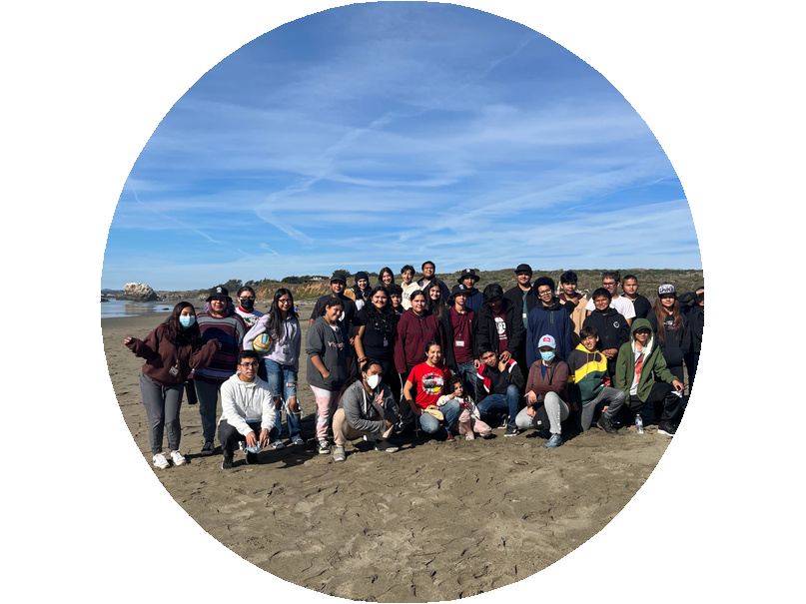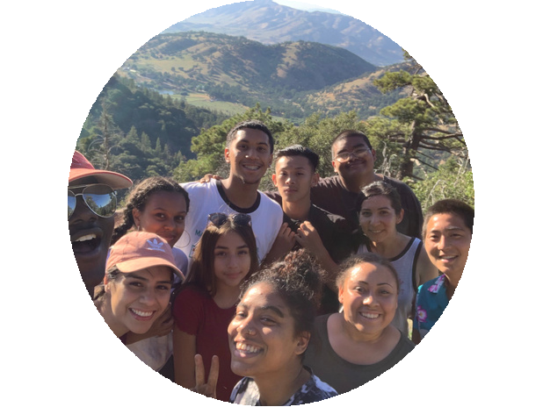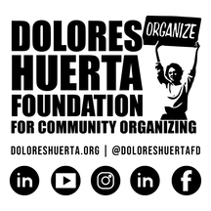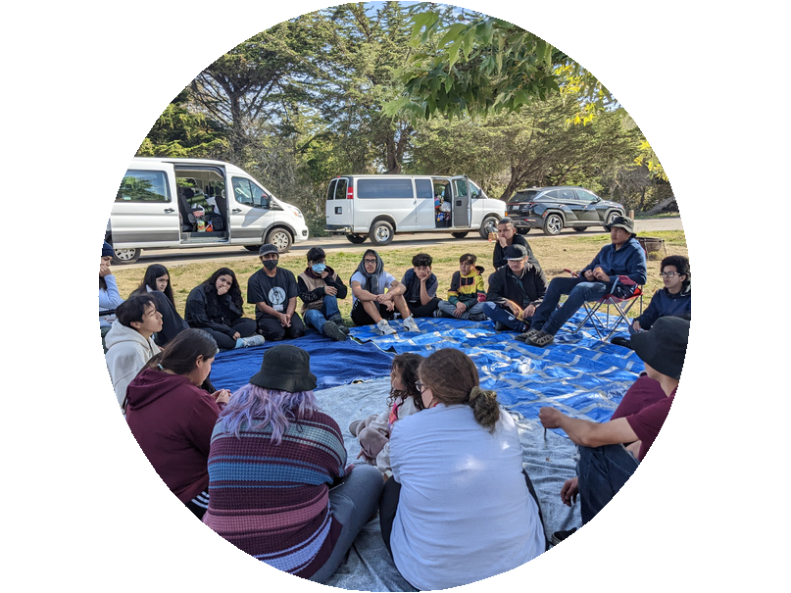

nDATion

Apply Today

**APPLICATIONS ARE DUE MAY 15, 2023 BY 5:00PM.**

**For more information, visit our website wwwdoloreshuerta.org or contact us today at camplyfe@doloreshuerta.org**